**WEEK-3**

**Spring Data JPA - Quick Example**

OrmLearnApplication.java

**package** com.cognizant.ormlearn;

**import** com.cognizant.ormlearn.model.Country;

**import** com.cognizant.ormlearn.repository.CountryRepository;

**import** org.springframework.beans.factory.annotation.Autowired;

**import** org.springframework.boot.CommandLineRunner;

**import** org.springframework.boot.SpringApplication;

**import** org.springframework.boot.autoconfigure.SpringBootApplication;

**import** java.util.List;

@SpringBootApplication

**public** **class** OrmLearnApplication **implements** CommandLineRunner {

@Autowired

**private** CountryRepository countryRepository;

**public** **static** **void** main(String[] args) {

SpringApplication.*run*(OrmLearnApplication.**class**, args);

}

@Override

**public** **void** run(String... args) **throws** Exception {

List<Country> countries = countryRepository.findAll();

System.***out***.println("All Countries:");

**for** (Country country : countries) {

System.***out***.println(country);

}

}

}

**OUTPUT:**

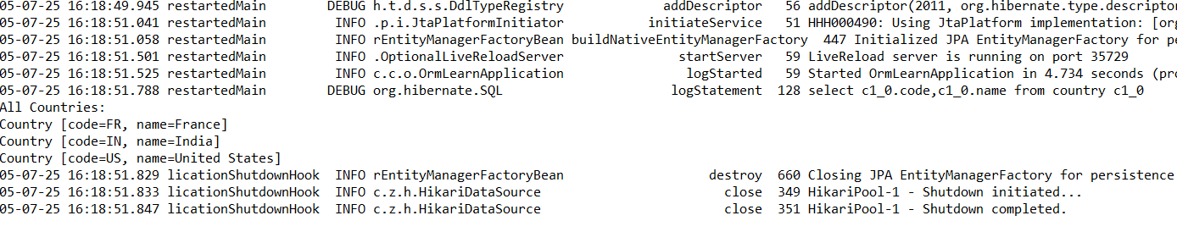

**Difference between JPA, Hibernate and Spring Data JPA**

EmployeeManagementApplication.java

**package** com.cognizant.employeemanagement;

**import** org.springframework.beans.factory.annotation.Autowired;

**import** org.springframework.boot.CommandLineRunner;

**import** org.springframework.stereotype.Component;

**import** com.cognizant.employeemanagement.model.Employee;

**import** com.cognizant.employeemanagement.service.EmployeeService;

@Component

**public** **class** EmployeeRunner **implements** CommandLineRunner {

@Autowired

**private** EmployeeService employeeService;

@Override

**public** **void** run(String... args) **throws** Exception {

System.***out***.println("Adding employees...");

Employee emp1 = **new** Employee(1, "Hairunisha", 55000.0);

Employee emp2 = **new** Employee(2, "Asraf", 60000.0);

employeeService.addEmployee(emp1);

employeeService.addEmployee(emp2);

System.***out***.println("Employees added!");

}

}

**OUTPUT:**

